Business Problem Statement
A leading retail company wants to better understand its customers’ shopping behaviour in order to improve sales, customer satisfaction, and long-term loyalty. The management team has noticed changes in purchasing patterns across demographics, product categories, and sales channels (online vs. offline). They are particularly interested in uncovering which factors, such as discounts, reviews, seasons, or payment preferences, drive consumer decisions and repeat purchases. You are tasked with analysing the company’s consumer behaviour dataset to answer the following overarching business question: How can the company leverage consumer shopping data to identify trends, improve customer engagement, and optimize marketing and product strategies?

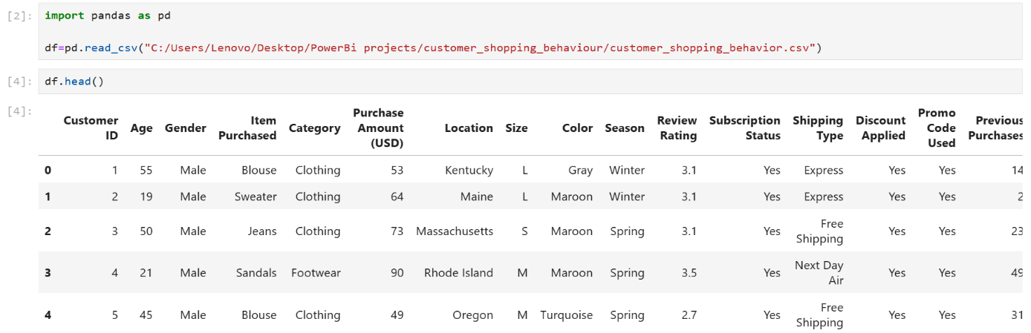

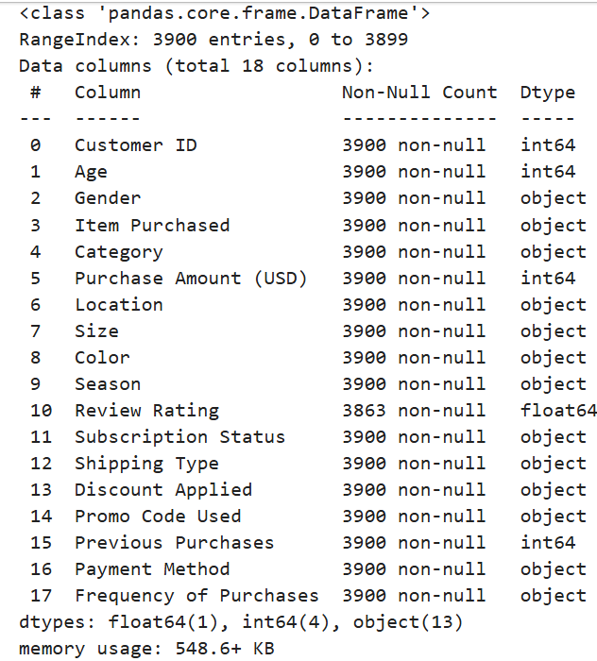
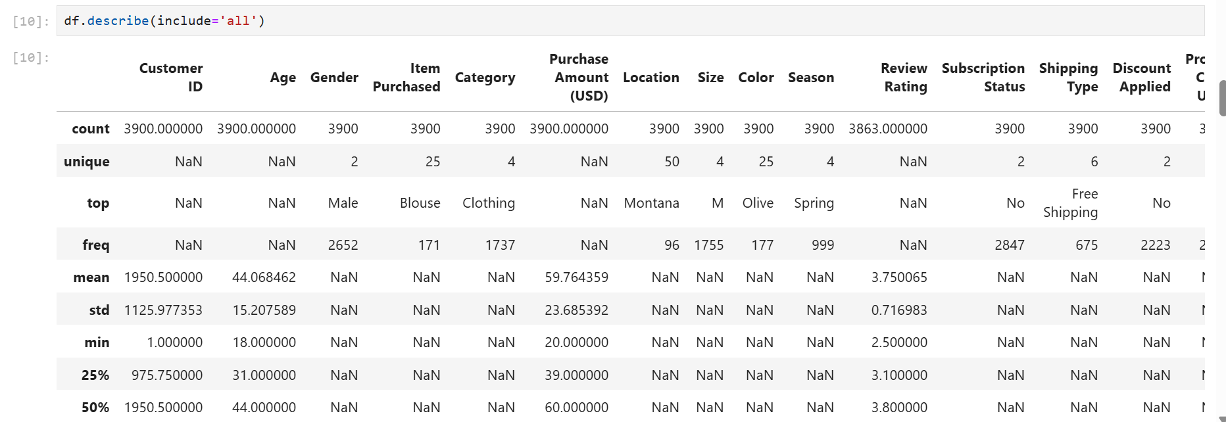

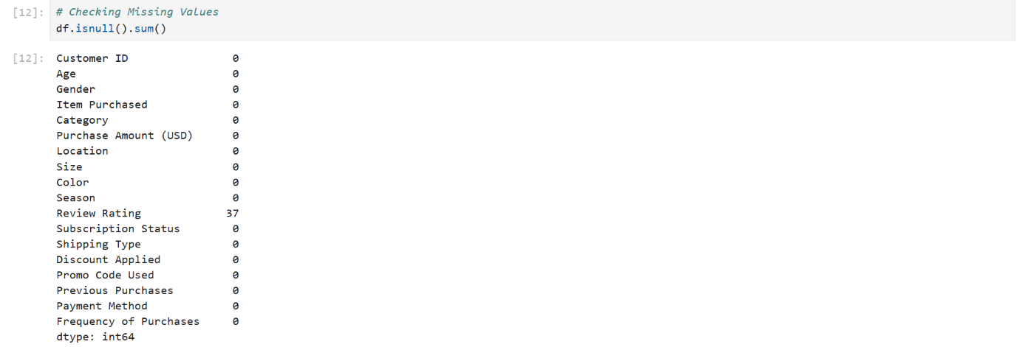
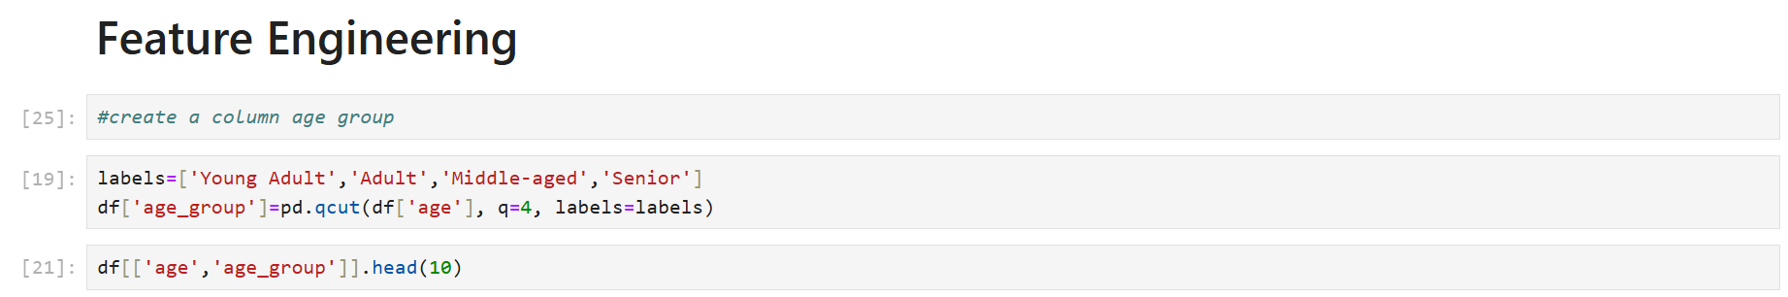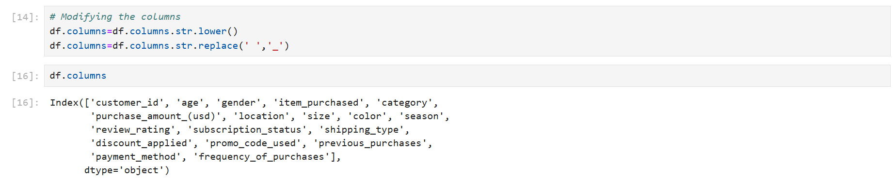
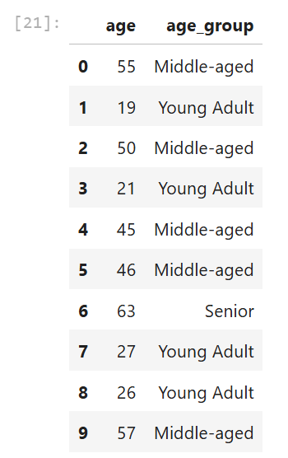
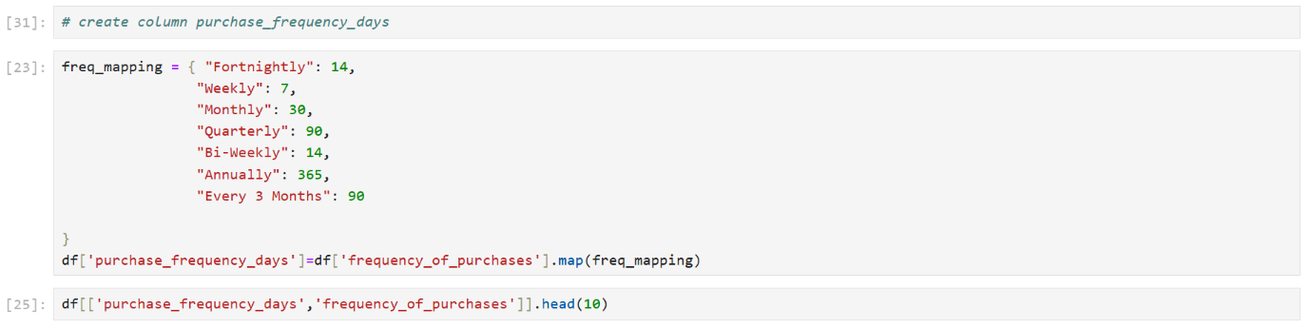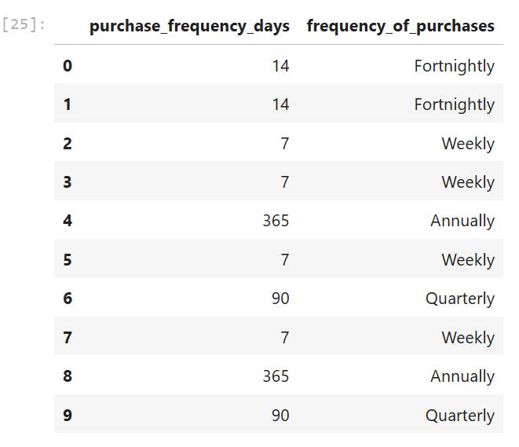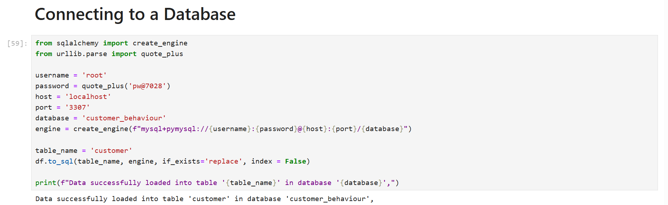

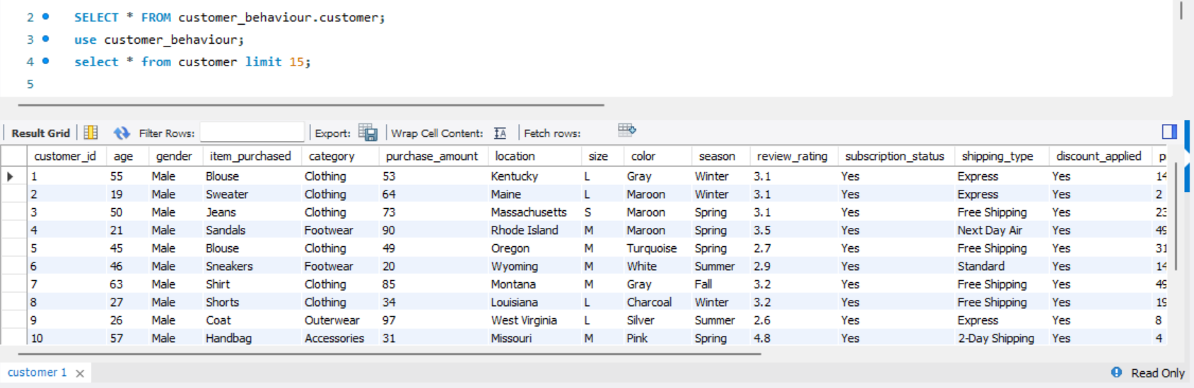

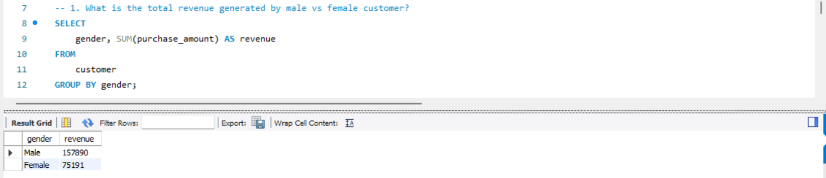

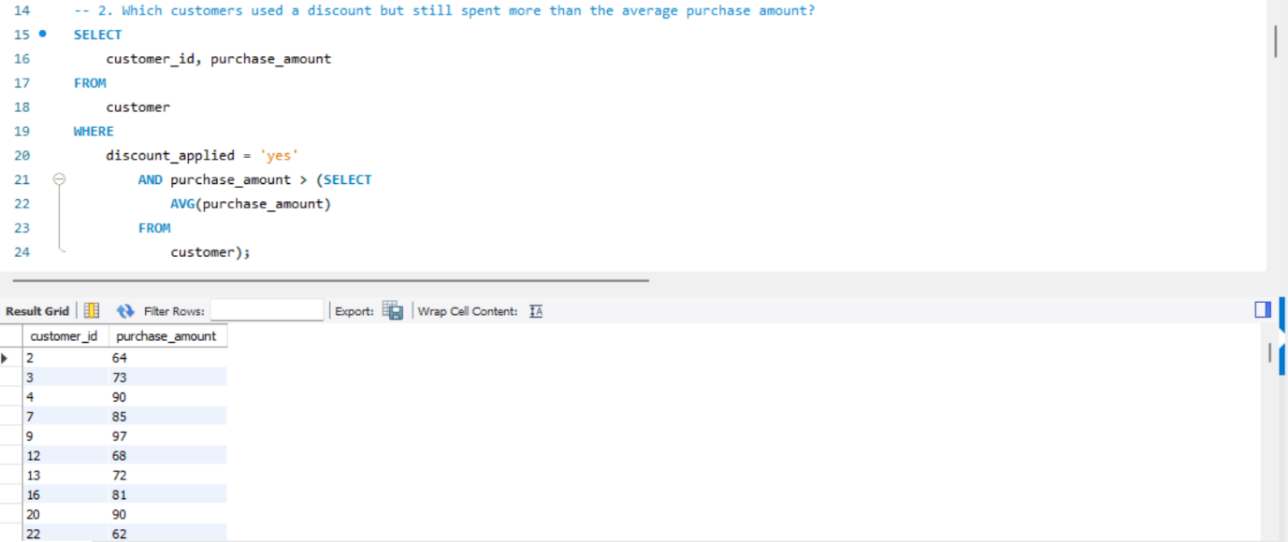

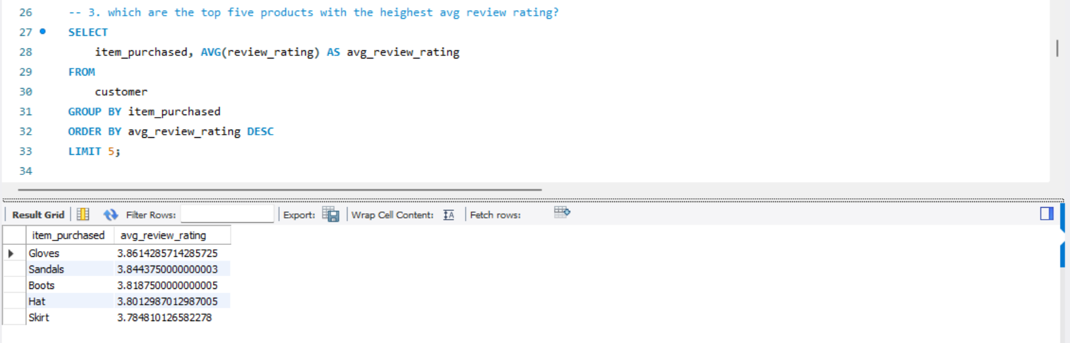

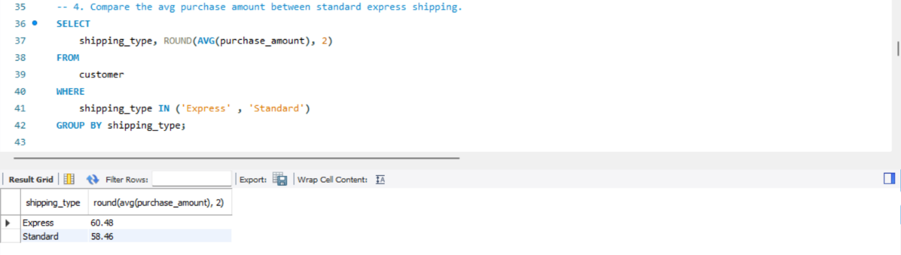

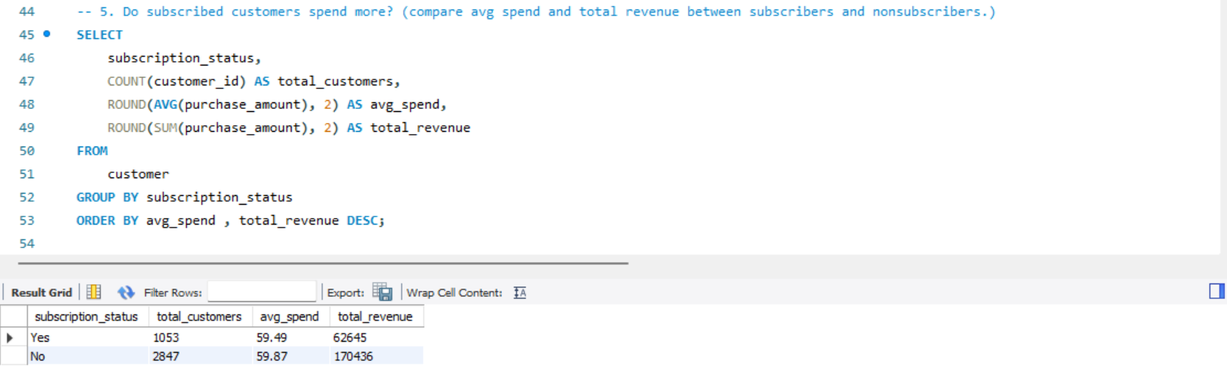
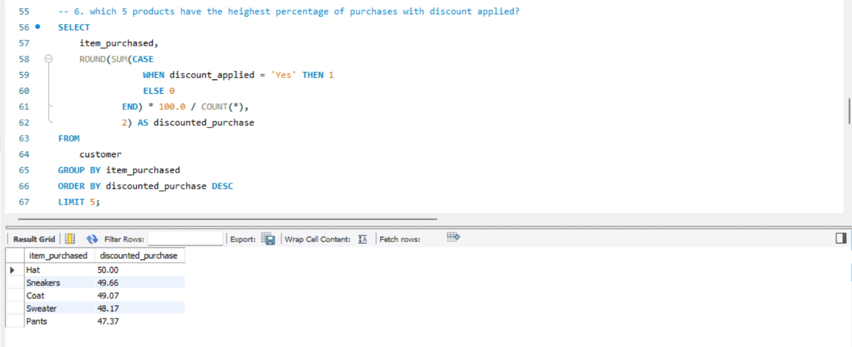
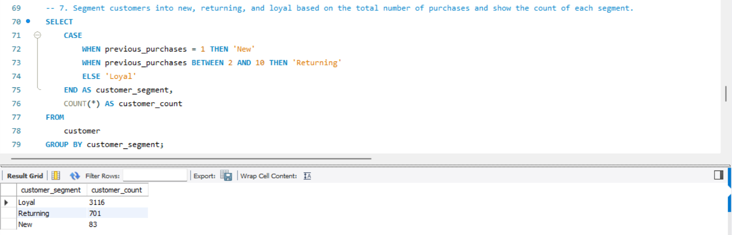

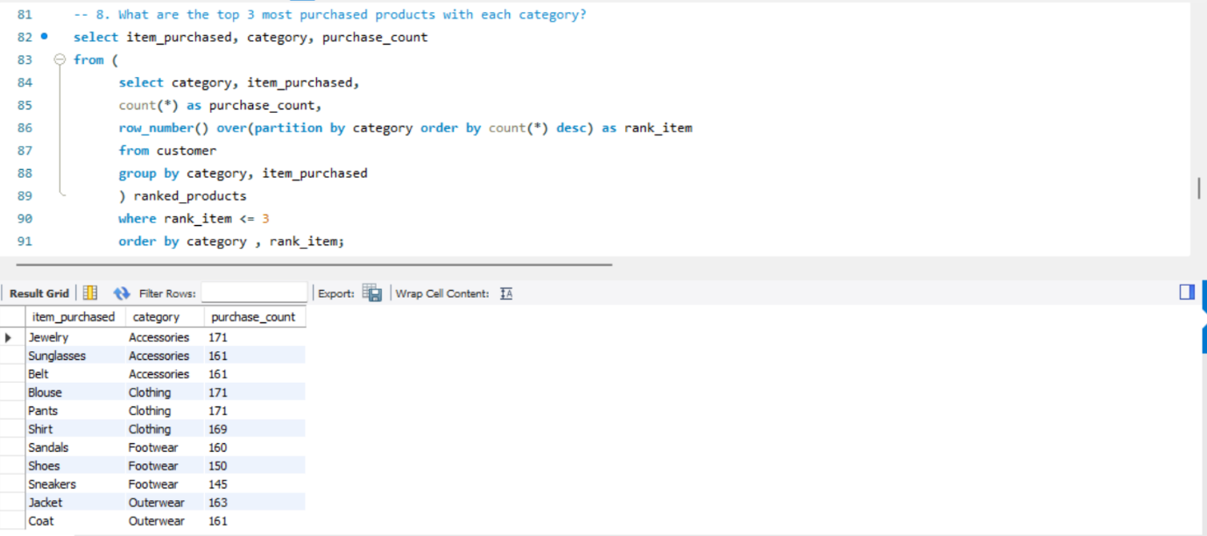
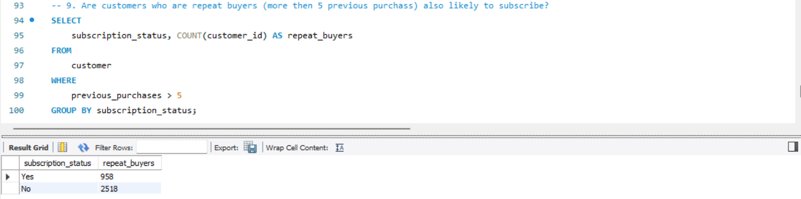

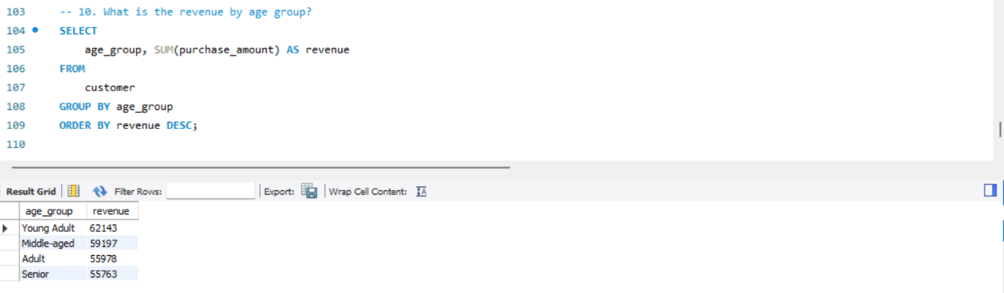
Power BI Dashboard

